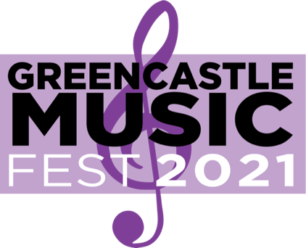
Greencastle Music Fest
17 W Franklin St
Greencastle, IN 46135
gailannsmith@tds.net
765-721-0137

Cornhole Tournament Registration Form
Saturday, August 28, 2021 @ 5:30 pm

Thank you for joining us in this tournament and for your support towards the Greencastle Music Fest. We look forward to watching your team play.

Fees: $20 per team (2-person teams).
Registration is in-person at the event from 3-5pm.
Tournament starts at 5:30pm.

Team Name:
Team Member 1:
Team Member 2:
Primary Contact Email:
Primary Contact Phone Number:

